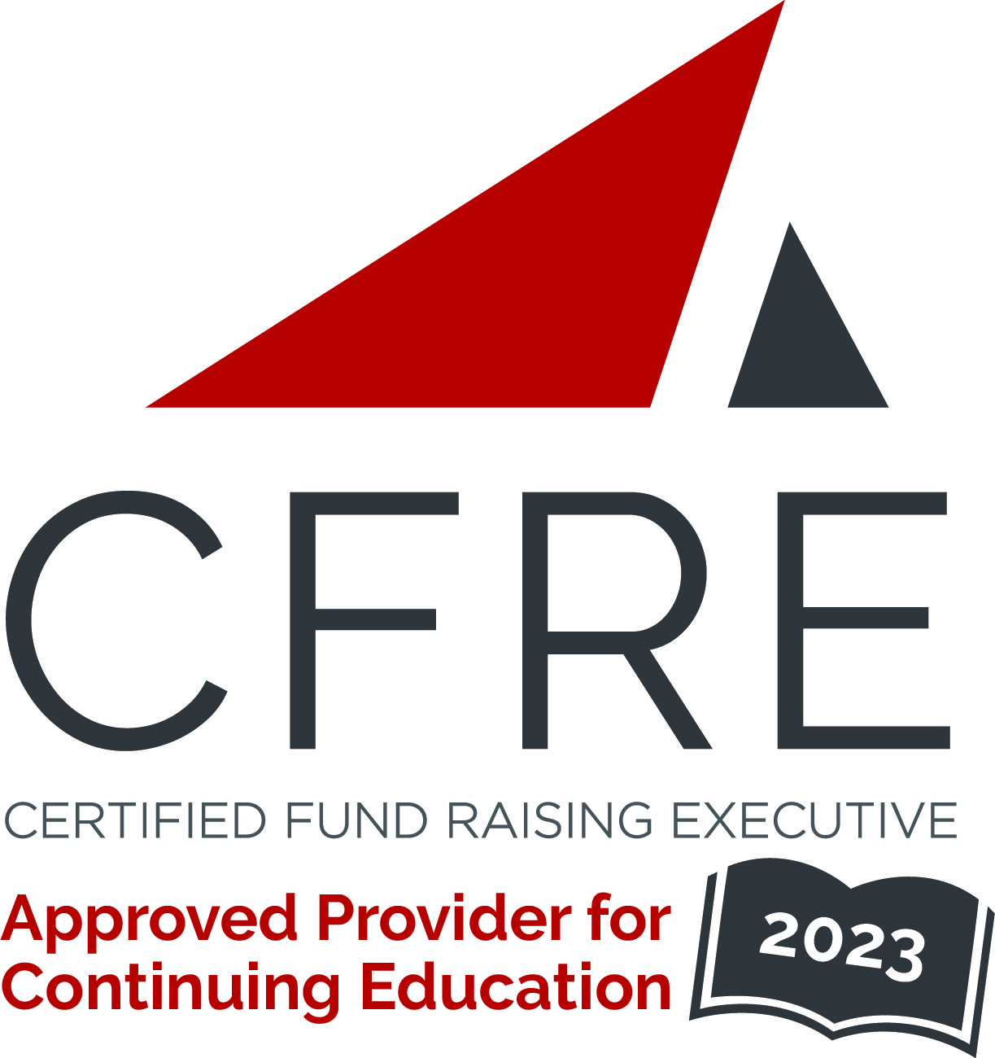  CFRE International has developed this form as a way for you to quickly track (and keep in your files!) the continuing education sessions you have attended. Simply check the boxes next to the sessions you attended. At the end of the conference, add up the total number of hours. Keep this sheet and you will be ready to complete your application form. All of the session slots listed are eligible for continuing education points on your CFRE application for initial certification and/or recertification. Sessions not listed here are not eligible for points. |  | CONTINUING EDUCATION POINTS TRACKER

Activity Organizer: - Canadian Council for the Advancement of Education
Title of Activity: - Summit for Alumni Leaders
Names of Presenter(s): - Various
Dates and Location: - 7-8 March, 2023 – Montreal Quebec, Canada

Date: 7 March, 2023
Session 1: 9:15 – 11:00 (1.75 pts)
- Enhancing Alumni Engagement

Date: 7 March, 2023
Session 2: 11:15 – 12:15 (1 pt)
- Young Alumni Programming Strategy & Forum

Date: 7 March, 2023
Session 3: 13:15 – 14:30 (1.25 pts)
- Canadian Alumni Survey

Date: 7 March, 2023
Session 4: 14:45 – 16:15 (1.5 pts)
- Bored of Boards & Discussion

Date: 8 March, 2023
Session 5: 10:00 – 11:15 (1.25 pts)
- Safe Space Session: Alumni Relations For a Changing World

Date: 8 March, 2023
Session 6: 11:30 – 12:30 (1 pt)
- Empathetic Leadership & Organizational Culture
- [Session Title]

Total number of points attained: __________

